Client – Confidential


Project Date
Vulnerability Assessment 14/10/25
Document Classification Version
Client Confidential 1
Prepared By Suvhankar Dutta

RECON ON CODELOGICX
- Legally registered in India
  - The company is CODELOGICX TECHNOLOGIES PRIVATE LIMITED with CIN U72300WB2013PTC191145. (ZaubaCorp)
  - It was incorporated on 4th March 2013. (InstaFinancials)
  - It is currently Active in the Ministry of Corporate Affairs (MCA) registry. (InstaFinancials)
  - Its authorized share capital is ₹2,00,00,000 and paid-up capital is same (₹2 Crores) per some company info sites. (InstaFinancials)
  - They have two listed directors: Amitabh Roy and Meghamala Roy. (ZaubaCorp)
  - They have an LEI (Legal Entity Identifier) registration: 984500J9C92EV02EA451, validating their legal identity in trade / finance contexts. (LEI Register)
- Employee feedback / reviews exist
  - On Glassdoor, they have an average employee rating of ~4.5 / 5 (based on ~50+ reviews). (Glassdoor)
  - Many reviews cite “friendly work environment,” “learning opportunities,” “salary on time.” (Glassdoor)
  - But there are also negative / cautionary reviews: complaints about management, favoritism, pressure, weekend work, etc. (Glassdoor)
  - On Indeed, some reviews describe a good work environment and learning exposure. (Indeed)
- Third-party profile / credibility in agency directories
  - DesignRush gives them a profile, people estimate their hourly rate ~$15/hr, employee size 100-249. (DesignRush)
  - JustDial (a local directory) shows them in Kolkata with ~4.4 rating from ~78 reviews. (Justdial)
- Claims & self-presented achievements
  - They claim awards like “SaaS Company of the Year” at TechMeet 2024 (by ASSOCHAM) for their in-house product TeamTrace. (CodelogicX)
  - They list many technology capabilities, global offices, and a narrative of growth since 2013. (CodelogicX)

Weaknesses, red flags, or areas needing more verification
- Marketing claims without strong evidence
  - “Nearly 100% client retention,” “95% project success rate,” etc. are self-claims. Need to verify via client references or third-party reviews. (CodelogicX)
  - Awards / recognitions need verification: local awards and event claims are easier to self-promote. Always ask for proof (certificates, press releases).
- Employee reviews contain serious criticisms
  - Some reviews allege “incompetent managers,” “favoritism,” “weekend work is expected/enforced,” etc. (Glassdoor)
  - These negative reviews suggest potential cultural / management risks, especially for long term or sensitive projects.
- Financials / revenue not transparent in public domain
  - The public registries mention capital / balance sheet filing, but I did not find reliable recent revenue, profit, or audited reports in open sources. (InstaFinancials)
  - The “revenue < $1 million USD” mention on Glassdoor (as a profile estimate) is a signal that they may be small in scale compared to big IT firms. (Glassdoor)
- Client feedback / independent references lacked in my search
  - I did not find many case studies from independent sources about their completed projects, client testimonials outside their website, or press coverage verifying their claims.
  - No significant negative news / litigation (in my search) surfaced, but absence of evidence is not proof of absence.
- Local directory mixing of business types
  - On JustDial, some descriptions may misclassify the company (as an installation services provider). That could be generic or outdated listings. (Justdial)
  - Some directories may show mixed or mistaken categories. Be cautious on directory data.
SQL-injection tools
1) Automated scanners & enterprise tools
These run wide checks automatically and are good for broad coverage / scheduled scans.
• sqlmap — CLI automation for discovering and exploiting SQLi
(fingerprinting DB, extracting data). Great for fast, deep checks in a lab. (Cross-platform, Python).
Defender note: watch for automated, repetitive query patterns.
• Acunetix — Commercial web scanner with built-in SQLi checks and enterprise reporting/CI integrations.
Defender note: use for scheduled scans in pre-prod and triage false positives manually.
• Netsparker / Invicti — Commercial scanner focused on accuracy and proof-based detection to reduce false positives.
Defender note: integrates with ticketing to push fixes to dev teams.
• OWASP ZAP — Open-source scanner + proxy; good for automated baseline scans and CI pipeline integration. (Java)
Defender note: run in staging to catch regressions early.

2) Manual testing & proxy tools
Used by testers to craft, manipulate, and validate payloads interactively.
• Burp Suite (Proxy / Repeater / Intruder / Scanner) — Industry standard for manual web testing; craft requests, fuzz, and validate SQLi.
(Community & Pro)
Defender note: manual probing often leaves long sequences of similar requests — monitor for that.
• Tamper Data / browser devtools — Browser tools/addons for
intercepting and editing requests manually. Essential for quick proofs-of- concept.
Defender note: strong server-side validation prevents these manual attacks.
• curl / HTTPie — Command-line HTTP clients for crafting custom requests; good for reproducible POCs or scripts.
Defender note: logs will show unusual content in parameters when attacks occur.

3) DB-specific exploitation tools
Target particular DB engines or provide DB-centric post-exploitation features.
• sqlninja — Focused on Microsoft SQL Server exploitation and post- exploit actions.
Defender note: harden MSSQL (disable dangerous extended procedures, enforce least privilege).
• sqlsus — Tool aimed at MySQL SQLi exploitation and extraction (CLI).
Defender note: separate DB accounts and remove unnecessary privileges.
• jSQL Injection — Java GUI tool that automates detection/extraction across many DB types (beginner-friendly).
Defender note: GUI tools are noisy — WAFs often have signatures.
• Havij — Automated Windows GUI SQLi tool (historically popular). Use only in safe labs — it’s often detected by security controls.
Defender note: rely on secure coding rather than only WAF signatures.

4) Fuzzers & blind SQLi helpers
Designed to enumerate injection points, brute-force payloads, or extract data via blind channels.
• BBQSQL — A blind SQLi fuzzer and extraction tool (Python) designed for time/boolean based blind attacks.
Defender note: blind attacks generate many slow, patterned requests — watch for timing anomalies.
• WFuzz — Generic web fuzzer useful to brute force parameter values and test payloads.
Defender note: rate-limit and alert on high request bursts.
• SQLiv — Automated SQL injection scanner that helps find injectable URLs from lists (CLI).
Defender note: scanning tools often probe many parameters; block or throttle unauthenticated scanning.

5) Recon / enumeration / supporting tools
Not pure SQLi tools but useful in the discovery phase to find targets, endpoints, versions, and configurations.
• Nmap (with NSE scripts) — Network/service discovery and scripts that can fingerprint DB services and versions. Useful pre-engagement recon. Defender note: minimize exposed DB ports; use network segmentation.

• Nikto — Web server scanner to find outdated software, CGI scripts, and misconfigurations that might lead to injection vectors.
Defender note: patch and reduce server info exposure.
• DirBuster / Dirsearch — Directory and file bruteforcers to discover hidden endpoints/parameters that could be injectable.
Defender note: hide or protect admin/endpoints and require auth.

6) NoSQL & non-SQL injection tools
For apps using NoSQL databases (different injection patterns).
• NoSQLMap — Automated tool for detecting/exploiting NoSQL injection (MongoDB, etc.). Targets operator injection and JSON payload issues. Defender note: validate types and use safe query builders; don’t build queries from raw JSON from users.
7) Exploitation frameworks & post-exploit tools
Used when SQLi can be chained to further compromise (authorized red-team).
• Metasploit Framework — Large exploitation framework with modules useful for post-exploitation after gaining DB access or a shell.
Defender note: monitor for lateral movement and abnormal process/command activity.

8) Other SQLi helpers / one-offs you may see
• SQLi Dumper / SQLi tools — Various smaller or less reputable tools exist; they often automate extraction but may be outdated or malicious.
Defender note: WAF signatures often include such tool fingerprints — but do not rely solely on signatures.

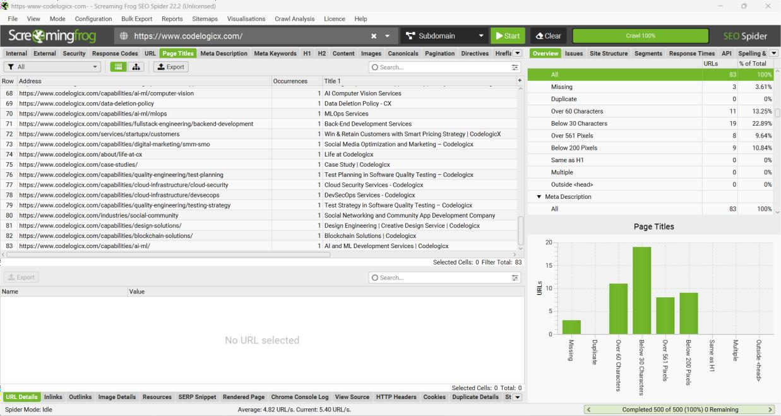
No of Web pages:- 83 Proof of concept:-
1. https://www.codelogicx.com/
2. https://www.codelogicx.com/capabilities/design-solutions/social-media- creatives-design
3. https://www.codelogicx.com/capabilities/quality-engineering/ci-cd-testing
4. https://www.codelogicx.com/capabilities/mobile-engineering/ios-app- development
5. https://www.codelogicx.com/services/maintenance-upgrades
6. https://www.codelogicx.com/capabilities/quality-engineering/specialized- testing
7. https://www.codelogicx.com/privacy-policy
8. https://www.codelogicx.com/industries/fintech-app-development
9. https://www.codelogicx.com/terms-of-service
10. https://www.codelogicx.com/services/staff-augmentation
11. https://www.codelogicx.com/capabilities/fullstack-engineering/web-app- development
12. https://www.codelogicx.com/capabilities/quality-engineering/functional- testing
13. https://www.codelogicx.com/capabilities/ai-ml/edge-ai
14. https://www.codelogicx.com/industries/healthcare-software-development
15. https://www.codelogicx.com/about/locations
16. https://www.codelogicx.com/contact
17. https://www.codelogicx.com/capabilities/ai-ml/agent-chatbots
18. https://www.codelogicx.com/capabilities/cloud-infrastructure/dr-solutions
19. https://www.codelogicx.com/about/safe-workplace
20. https://www.codelogicx.com/cookie-policy
21. https://www.codelogicx.com/industries/transport-software-development
22. https://www.codelogicx.com/capabilities/quality-engineering/manual- testing
23. https://www.codelogicx.com/capabilities/cloud-infrastructure/kubernetes- solutions
24. https://www.codelogicx.com/industries/retail-ecommerce
25. https://www.codelogicx.com/capabilities/quality-engineering/test- automation
26. https://www.codelogicx.com/services/startupx/planning
27. https://www.codelogicx.com/capabilities/cloud-infrastructure/devops- enablement
28. https://www.codelogicx.com/services/startupx/product
29. https://www.codelogicx.com/services/startupx/launch
30. https://www.codelogicx.com/capabilities/quality-engineering/api-testing
31. https://www.codelogicx.com/capabilities/mobile-engineering/app- maintenance
32. https://www.codelogicx.com/capabilities/cloud-infrastructure/cost- optimization
33. https://www.codelogicx.com/capabilities/mobile-engineering/app- modernization
34. https://www.codelogicx.com/capabilities/mobile-engineering/flutter-app- development
35. https://www.codelogicx.com/capabilities/mobile-engineering/web-app- development
36. https://www.codelogicx.com/capabilities/digital-marketing/seo
37. https://www.codelogicx.com/capabilities/design-solutions/ui-ux-design
38. https://www.codelogicx.com/capabilities/digital-marketing/ppc
39. https://www.codelogicx.com/capabilities/mobile-engineering/react-app- development
40. https://www.codelogicx.com/services/startupx/
41. https://www.codelogicx.com/capabilities/design-solutions/product-design
42. https://www.codelogicx.com/services/software-rescue-services
43. https://www.codelogicx.com/capabilities/ai-ml/generative-ai
44. https://www.codelogicx.com/industries/hr-payroll-software-development
45. https://www.codelogicx.com/capabilities/quality-engineering/performance- testing
46. https://www.codelogicx.com/capabilities/fullstack-engineering/frontend- development
47. https://www.codelogicx.com/capabilities/fullstack-engineering/ai- integration
48. https://www.codelogicx.com/industries/travel-hospitality-software- development
49. https://www.codelogicx.com/capabilities/mobile-engineering/android-app- development
50. https://www.codelogicx.com/about/values
51. https://www.codelogicx.com/services/startupx/scale
52. https://www.codelogicx.com/capabilities/ai-ml/nlp-llm
53. https://www.codelogicx.com/capabilities/cloud-infrastructure/cloud- managed-service
54. https://www.codelogicx.com/capabilities/cloud-infrastructure/site- reliability
55. https://www.codelogicx.com/capabilities/design-solutions/brand-design
56. https://www.codelogicx.com/capabilities/fullstack-engineering/api- integration
57. https://www.codelogicx.com/capabilities/cloud-infrastructure/cloud- migration
58. https://www.codelogicx.com/capabilities/ai-ml/recommender-systems
59. https://www.codelogicx.com/industries/education
60. https://www.codelogicx.com/services/code-infrastructure-audits
61. https://www.codelogicx.com/services/product-engineering
62. https://www.codelogicx.com/capabilities/digital-marketing/content- marketing
63. https://www.codelogicx.com/capabilities/cloud-infrastructure/cloud- modernization
64. https://www.codelogicx.com/capabilities/digital-marketing/email- marketing
65. https://www.codelogicx.com/capabilities/ai-ml/deep-learning
66. https://www.codelogicx.com/capabilities/ai-ml/computer-vision
67. https://www.codelogicx.com/services/scaling-optimization-support
68. https://www.codelogicx.com/capabilities/quality-engineering/mobile-app- testing
69. https://www.codelogicx.com/capabilities/ai-ml/mlops
70. https://www.codelogicx.com/capabilities/fullstack-engineering/backend- development
71. https://www.codelogicx.com/data-deletion-policy
72. https://www.codelogicx.com/capabilities/digital-marketing/smm-smo
73. https://www.codelogicx.com/about/life-at-cx
74. https://www.codelogicx.com/capabilities/quality-engineering/test-planning
75. https://www.codelogicx.com/services/startupx/customers
76. https://www.codelogicx.com/case-studies/
77. https://www.codelogicx.com/capabilities/cloud-infrastructure/cloud- security
78. https://www.codelogicx.com/capabilities/cloud-infrastructure/devsecops
79. https://www.codelogicx.com/capabilities/quality-engineering/testing- strategy
80. https://www.codelogicx.com/industries/social-community
81. https://www.codelogicx.com/capabilities/design-solutions/
82. https://www.codelogicx.com/capabilities/blockchain-solutions/
83. https://www.codelogicx.com/capabilities/ai-ml/

